Report for Independent Study Module

By  
Reuben X. Wang  
A0149634X

Advisor  
Assoc Prof Feng Chen-Chieh

Department of Geography  
National University of Singapore

# History

## The First Separation of Singapore from Malaya

Pre-war Singapore was the capital of the British Crown Colony of the Straits Settlement. Along with Singapore, major territories of the Straits Settlements included the mainland settlements of Penang and Malacca. After the Japanese and Thai occupation of 1942-1945, the British returned a peninsular ripe with ethnic conflict and lawlessness. Nevertheless, they followed through on their planned rationalisation of British holdings in Malaya. The Straits Settlements were dissolved in 1946. Penang, Malacca, and their dependencies was subsequently transferred into the colony of the Malayan Union, while Singapore was turned into its own Crown Colony. This new political-geographical division of Singapore and (to-be) Malaysia[1] was attributable to an increased importance of Malaya within the British Empire and to the United Kingdom. The impending independence of India resulted in a heightened importance of Malaya and Brunei as the sole colonies between Africa and Hong Kong. India and Pakistan’s independence also left Malaya as the sole major producer of tin and rubber within the Empire. These commodities were important not merely for reasons of self-sufficiency, but as a source of raw resources for the factories of the metropolitan United Kingdom. These resources were also critical sources of exports to prop up the flailing Sterling Area. (Stockwell, 1999) Singapore “was expected to become “a sort of District of Columbia”, the headquarters of the British Governor-General for Southeast Asia, with its own local government.” (Turnbull, 2009, p. 228) Singapore was also held due to its military importance in a region of great power rivalry. Although the re-organisation of British Malaya took Singaporeans were taken by surprise, Singaporeans were either apathetic or disempowered to resist the *fait accompli*. The British did not oppose a future union between Singapore and Malaysia. Nevertheless, the Chinese Chamber of Commerce echoed most objections by arguing Singapore is “the centre of Malayan economy, politics, and culture”. (Turnbull, 2009, p. 233)

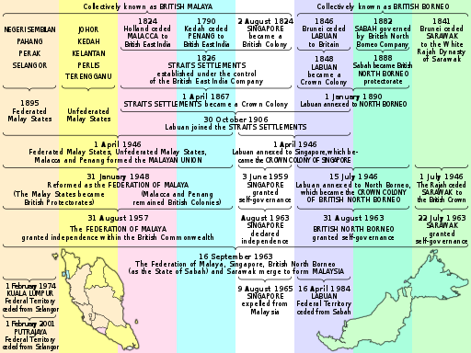  
Figure 2. The political evolution of Singapore and Malaysia. Adapted from <https://commons.wikimedia.org/wiki/File:Malaysia_tree_diagram.svg>, CC BY-SA 3.0

## Literature Review

Although the Legislative Elections of 1955 are generally depicted as a pivotal event in the development of politics in post-war and pre-independence Singapore, there is relatively few academic surveys into the specific event of the election. Thus, any literature survey must necessarily be broad to capture academic sources which only covers the election in passing.

C. M. Turnbull’s venerable *Modern History of Singapore* (Turnbull, 2009) provides a condensed one-and-a-half overview of historical and political trends during the relevant period. In this work, the Elections of 1955 are depicted as a bridge between two eras of Singaporean history. It was, firstly, the culmination of a decade long project of nation-building and education in self-governance by the British colonial administration. This nation-building project was carried out in the context of post-1) war economic recovery, 2) the advent of ethno-nationalism amongst Malay, Indian, and Chinese communities in British Southeast Asia, and 3) the ascendency and subsequent insurgency of the Malaya Communist Party.

# Biblography

Stockwell, A. J. (1999). Southeast Asia in War and Peace: The End of European Colonial Empires. In N. Tarling (Ed.), *The Cambridge History of Southeast Asia Volume Two, Part Two: From Wolrd War II to the present* (pp. 1–58). Cambridge: Cambridge University Press.

Turnbull, C. M. (2009). *A Modern History of Singapore, 1819-2005*. Singapore: NUS Press.

1. Although there are numerous important events between the 1946 redrawing of borders and the foundation and Singapore’s secession, I will use “to-be Malaysia” as a shorthand for the geographical territories that would eventually become modern Malaysia.